Chapter 19, Solution 5.

Obtain the z parameters for the network in Fig.19.69 as functions of s.

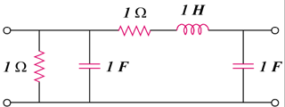

1 Ω

1 F

1 H

1 Ω

1 F

Figure 19.69
For Prob. 19.5

Solution

Consider the circuit in Fig. (a).

I₂ = 0

1

+

V₁

1

I₁

(a)

+

V₂

s

1/s

1/s

I_{o}

Consider the circuit in Fig. (b).

+

V₂

I₂

+

V₁

I₁ = 0

1

1

(b)

s

1/s

1/s

Hence,

